Strategy Pattern

Defines a family of algorithms (that we want to use), encapsulates each one, and makes them interchangeable (değiş tokuş edilebilir). Meaning that you can plug and play. Sometimes using Algorithm A , sometimes Algorithm B and so on.
Strategy lets the algorithm vary independently from clients that use it. We separate the Algorithm from the one that uses it, from the client. We don’t need to change the client if we change the algorithm in use. The client can stay the same and only the algorithm will change.

For example : an Implementation of a Collection , a List class. If the list has a sorting algorithm built into it we could never change the sorting algorithm but we could use a strategy pattern and inject a sorting strategy (Interface). Our concrete implementations of different sorting algorithms will implement this SortingStrategy interface. Our List class will ‘choose’ which sorting algorithm it wants to implement during runtime and it can change easily without effecting anything in the List Class’ implementation. (UML Class diagram might be false)

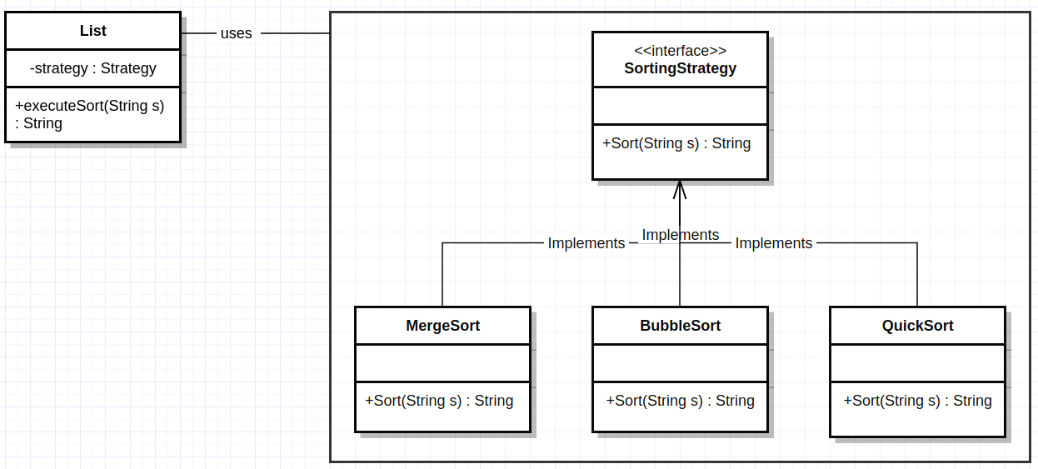
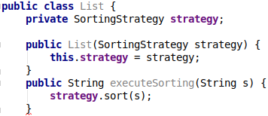
interface SortingStrategy {
public String sort(String s);
}

public class MergeSort implements SortingStrategy {
@Override
public String sort(String s) {
// MergeSort implementation
return null;
}
}

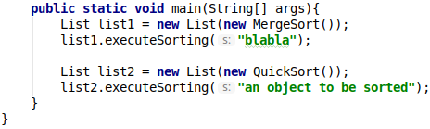
public class BubbleSort implements SortingStrategy {
@Override
public String sort(String s) {
// BubbleSort implementation
return null;
}
}

public class QuickSort implements SortingStrategy {
@Override
public String sort(String s) {
// QuickSort implementation
return null;
}
}
In computer programming, the strategy pattern (also known as the policy pattern) is a behavioral software design pattern that enables selecting an algorithm at runtime. The strategy pattern
- defines a family of algorithms,
- encapsulates each algorithm, and
- makes the algorithms interchangeable within that family (is the Interface/Strategy).

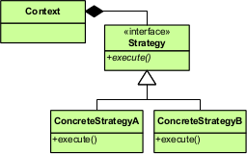
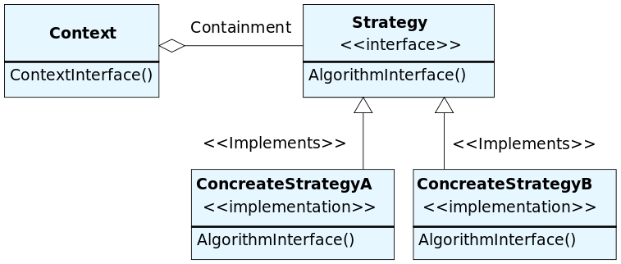

The Strategy design pattern is one of the twenty-three well-known GoF design patterns that describe how to solve recurring design problems to design flexible and reusable object-oriented software, that is, objects that are easier to implement, change, test, and reuse.

What problems can the Strategy design pattern solve?

- A class should be configured with an algorithm instead of implementing an algorithm directly.
- An algorithm should be selected and exchanged at run-time.

Implementing an algorithm directly within the class that uses the algorithm is inflexible because it commits the class to a particular algorithm at compile-time and makes it impossible to change the algorithm later independently from (without having to change) the class. This also stops the class from being reusable when an other algorithm should be used.

What solution does the Strategy design pattern describe?

- Define a separate (strategy) object that encapsulates an algorithm. That is, define an interface (Strategy) for performing an algorithm, and define classes that implement the interface (algorithm) in different ways.
- A class delegates (yetki vermek) an algorithm to a strategy object at run-time instead of implementing an algorithm directly (that is, instead of committing to an algorithm at compile-time).

This makes a class independent of a particular algorithm (how an algorithm is implemented). A class can be configured with a strategy object, which is used to perform an algorithm. Moreover, the strategy object can be exchanged at run-time.

Strategy and open/closed principle

- In object-oriented programming, the open/closed principle states "software entities (classes, modules, functions, etc.) should be open for extension, but closed for modification"; that is, such an entity can allow its behaviour to be extended without modifying its source code.

According to the strategy pattern, the behaviors of a class should not be inherited. Instead they should be encapsulated using interfaces. As an example, consider a car class. Two possible functionalities for car are brake and accelerate.

Since accelerate and brake behaviors change frequently between models, a common approach is to implement these behaviors in subclasses. This approach has significant drawbacks: accelerate and brake behaviors must be declared in each new Car model. The work of managing these behaviors increases greatly as the number of models increases, and requires code to be duplicated across models. Additionally, it is not easy to determine the exact nature of the behavior for each model without investigating the code in each.

The strategy pattern uses composition instead of inheritance (important rule in general). In the strategy pattern, behaviors are defined as separate interfaces and specific classes that implement these interfaces. This allows better decoupling between the behavior and the class that uses the behavior. The behavior can be changed without breaking the classes that use it, and the classes can switch between behaviors by changing the specific implementation used without requiring any significant code changes. Behaviors can also be changed at run-time as well as at design-time. For instance, a car object’s brake behavior can be changed from BrakeWithABS() to Brake() by changing the brakeBehavior member to:

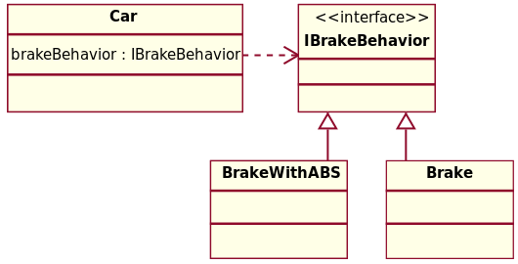

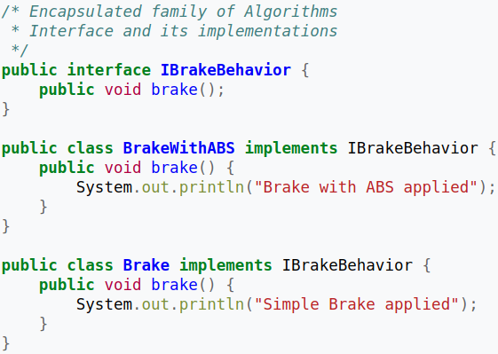

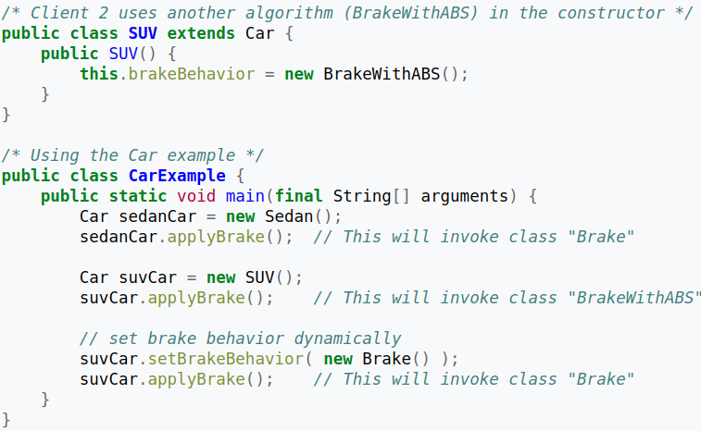
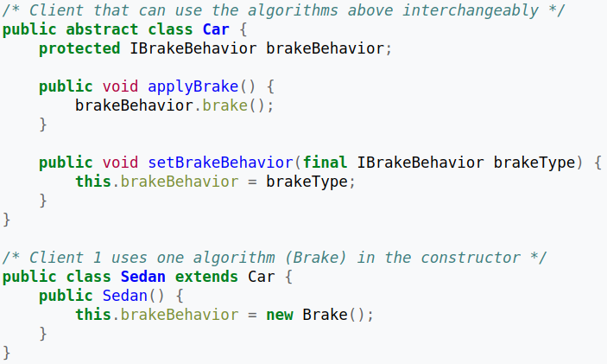

When to use Strategy Pattern ?
- When you want to define a class that will have one behavior that is similar to other behaviours in a list: (when you need to use one of several behaviors dynamically )
      - I want the class object to be able to choose from :
          - Not Flying
          - Fly slow with Wings
          - Fly Super Fast

- Eliminate duplicate code (inheritance)
- A superclass change shouldn’t break subclass code (inheritance)
- Avoid Interfaces that just force action ( Using interface just to force the creation of a method is a bad idea) (A lot of duplicate code)
- Composition : Behaviour can Change without side effects . The behaviour isn’t tied to the Superclass or Subclass

The other important theme to strategy pattern is that you decouple the decision about which strategy to use from the code that needs to execute the strategy.

The main reason for Strategy is explained in the GoF book p.316 that introduced the pattern:

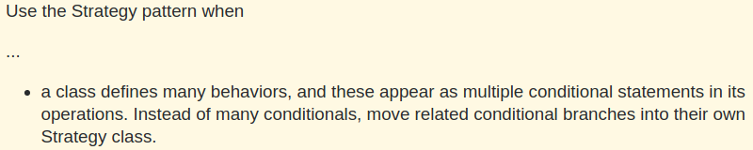

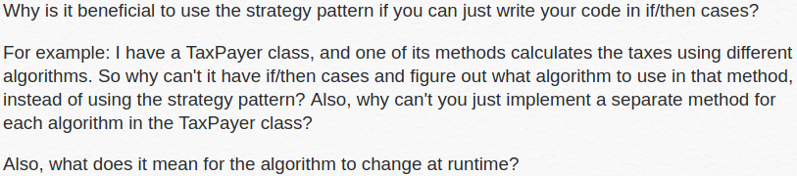
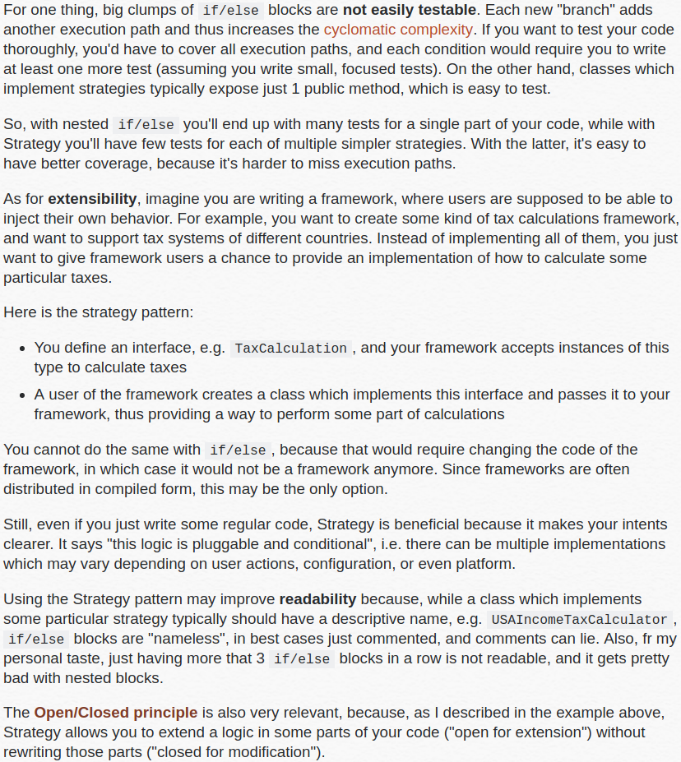
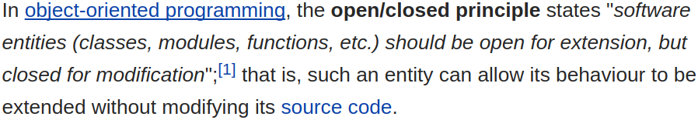

Observer Design Pattern

The observer pattern is a software design pattern in which an object, called the subject (observable), maintains a list of its dependents, called observers (Display, Reader , Subscriber), and notifies them automatically of any state changes, usually by calling one of their methods.

It is mainly used to implement distributed event handling systems, in "event driven" software. Most modern languages such as Java and C# have built in "event" constructs which implement the observer pattern components, for easy programming and short code.

The observer pattern is also a key part in the familiar model–view–controller (MVC) architectural pattern. The "View" part of Model-View-Controller. The observer pattern is implemented in numerous programming libraries and systems, including almost all GUI toolkits.

What problems can the Observer design pattern solve?

- A one-to-many dependency between objects should be defined without making the objects tightly coupled.
- It should be ensured that when one object changes state an open-ended number of dependent objects are updated automatically.
- It should be possible that one object can notify an open-ended number of other objects.

Defining a one-to-many dependency between objects by defining one object (subject) that updates the state of dependent objects directly is inflexible because it commits (tightly couples) the subject to particular dependent objects. Tightly coupled objects are hard to implement, change, test, and reuse because they refer to and know about (how to update) many different objects with different interfaces.

What solution does the Observer design pattern describe?

- Define Subject and Observer objects
- so that when a subject changes state, all registered observers are notified and updated automatically.

The sole responsibility of a subject is to maintain a list of observers and to notify them of state changes by calling their update() operation. The responsibility of observers is to register (and unregister) themselves on a subject (to get notified of state changes) and to update their state (synchronize their state with subject's state) when they are notified. This makes subject and observers loosely coupled. Subject and observers have no explicit knowledge of each other. Observers can be added and removed independently at run-time. This notification-registration interaction is also known as publish-subscribe.
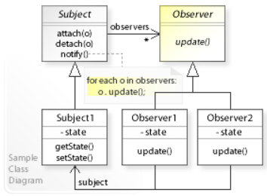
Typically, the observer pattern is implemented with the "subject" (which is being "observed") being part of the object whose state change is being observed, to be communicated to the observers upon occurrence.
This type of implementation is considered "tightly coupled" :

- forcing both the observers and the subject to be aware of each other and have access to their internal parts, creating possible issues of scalability, speed, message recovery and maintenance (also called event or notification loss), the lack of flexibility in conditional dispersion and possible hindrance to desired security measures
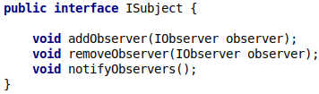
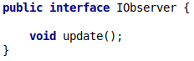

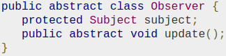

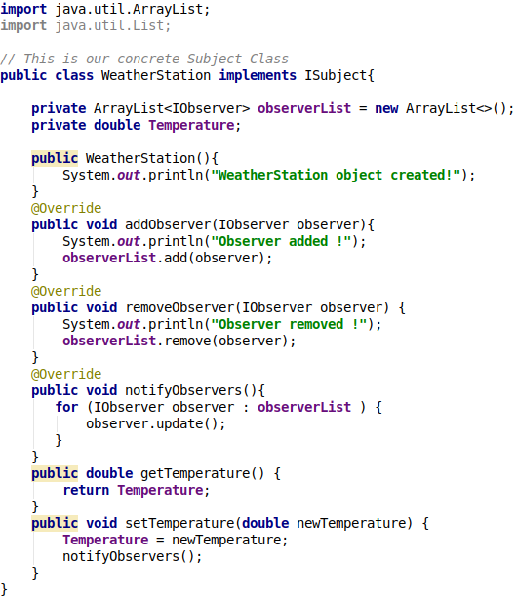

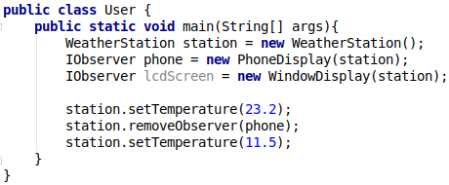

Output :
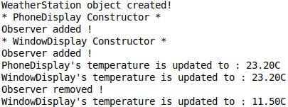

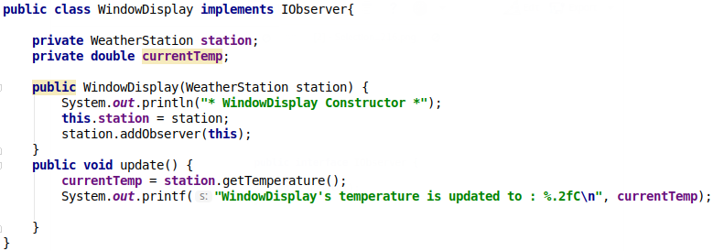

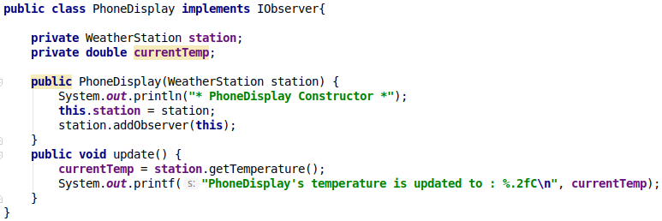

Decorator Pattern

In object-oriented programming, the decorator pattern (also known as Wrapper, an alternative naming shared with the Adapter pattern) is a design pattern that allows behavior to be added to an individual object, either statically or dynamically, without affecting the behavior of other objects from the same class. The decorator pattern is often useful for adhering to the Single Responsibility Principle, as it allows functionality to be divided between classes with unique areas of concern.

- The Decorator allows you to modify an object dynamically
- You would use it when you want the capabilities of inheritance with subclasses, but you need to add functionality at run time
- It is more flexible then inheritance
- Simplifies code because you add functionality using many simple classes
- Rather then rewrite old code you can extend with new code

The decorator pattern can be used to extend (decorate) the functionality of a certain object statically, or in some cases at run-time, independently of other instances of the same class, provided some groundwork is done at design time. This is achieved by designing a new Decorator class that wraps the original class. This wrapping could be achieved by the following sequence of steps:

- Subclass the original Component class into a Decorator class (see UML diagram);
- In the Decorator class, add a Component pointer as a field;
- In the Decorator class, pass a Component to the Decorator constructor to initialize the Component pointer;
- In the Decorator class, forward all Component methods to the Component pointer; and
- In the ConcreteDecorator class, override any Component method(s) whose behavior needs to be modified.

This pattern is designed so that multiple decorators can be stacked on top of each other, each time adding a new functionality to the overridden method(s).

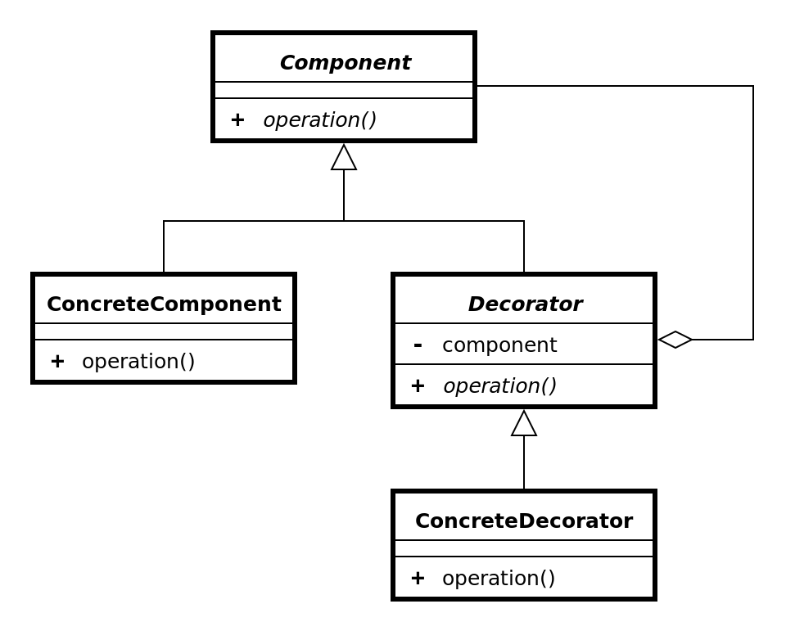

- If we try to create a class for every possible scenario / combination we would get a class explosion.

Lets say our base abstract class is pizza , and every concrete pizza option we have will be subclasses of pizza. Then we get infinitely many options that we all should somehow turn into a different class.

Pizza with cheese , Pizza with salami , pizza with salami and cheese , pizza with salami , cheese , tuna ……...

Lets say the price of cost is calculated off of each individual item . What happens if the price of salami goes up . Then we have to rewrite every single class that had salami in it.

Inheritance → Static
Composition → Dynamic

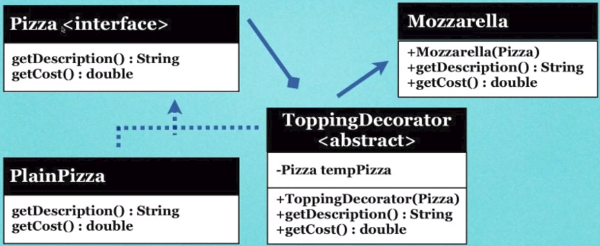
Through composition we will be able to add new functionalities by writing new code , rather then by changing current code.

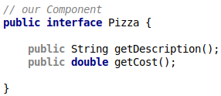

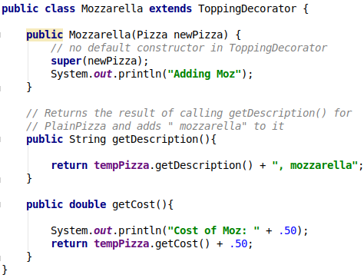

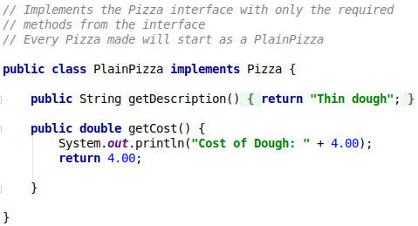

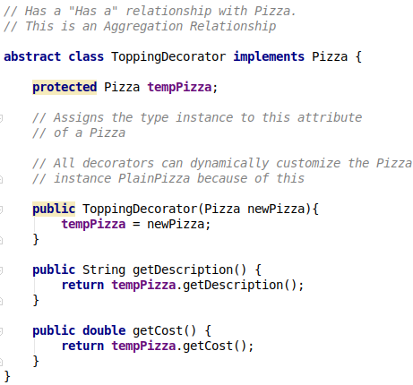
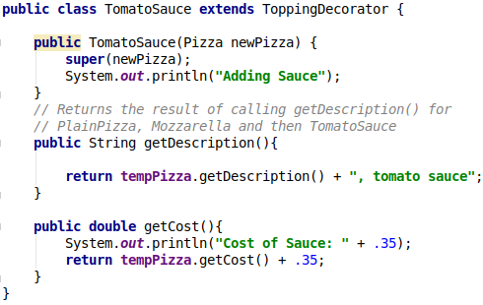

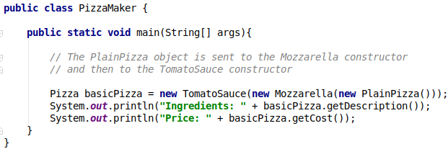

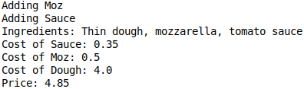

Singleton Pattern

- Many people argue that singleton pattern is a code smell and you should never use it. The main critique against it is the first thing we learn in programming is to avoid globals, to scope and enclose variables and functions so that they wont leak into the global space. One its extremely difficult to control , secondly whenever you leak something to the global namespace (globally accessible), that thing might change without you knowing it. Much harder to reason about your program when you dont have control , dont know the scope of a particular thing.
- It is generally used when you are really sure that you will only have one instance of a class , now and also in the future. For example just one instance for a Chat application , but when you are successful and you want to change your app and make it so that you have multiple chatrooms that will be a problem.
The main point here is that we cant really assume something like this for the far future , we cant be %100 sure that we will only use one instance forever.
- Its completely fine to have just one instance of a class in your program but to force it , to make it impossible to have another instance comes with problems.

The singleton pattern assures that a class has only one instance and provides a global point of access to it. This pattern is used inside many other patterns (just like the command pattern is used all over the place).

This pattern involves a single class which is responsible to create an object while making sure that only a single object gets created. This class provides a way to access its only object which can be accessed directly without the need to instantiate the object of the class.This is useful when exactly one object is needed to coordinate actions across the system.
There are some who are critical of the singleton pattern and consider it to be an anti-pattern in that it is frequently used in scenarios where it is not beneficial, introduces unnecessary restrictions in situations where a sole instance of a class is not actually required, and introduces global state into an application

The Singleton design pattern solves problems like:
- How can it be ensured that a class has only one instance?
- How can the sole instance of a class be accessed easily?
- How can a class control its instantiation?
- How can the number of instances of a class be restricted?

The Singleton design pattern describes how to solve such problems:
- Hide the constructor of the class.
- Define a public static operation (getInstance()) that returns the sole instance of the class.

The key idea in this pattern is to make the class itself responsible for controlling its instantiation (that it is instantiated only once). The hidden constructor (declared private) ensures that the class can never be instantiated from outside the class.

The public static operation can be accessed easily by using the class name and operation name (Singleton.getInstance()).

The “only one instance can be created” rule can be bypassed / violated with the following (?) :
- Reflection
- Serialization/deserialization
- clone
- multi-threaded accesses
- multiple class loaders
- Garbage collection

Implementation
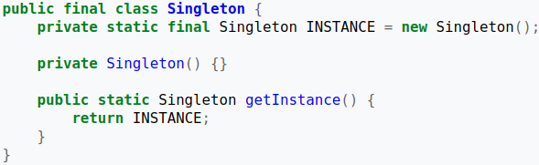

An implementation of the singleton pattern must:
- ensure that only one instance of the singleton class ever exists; and
- provide global access to that instance.

Typically, this is done by:
- declaring all constructors of the class to be private; and
- providing a static method that returns a reference to the instance.

The instance is usually stored as a private static variable; the instance is created when the variable is initialized, at some point before the static method is first called.

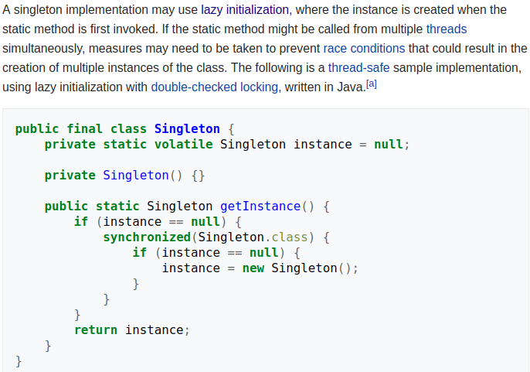

Command Pattern

The Command Pattern encapsulates a request as an Object thereby letting you parameterize other Objects with different requests queue or log requests and support undoable operations (operations which can be reverted back / which supports an undo operation).

- We have an Object , somebody sends a request to that object to do something, that request is what we will try to encapsulate. Not the receiver (the object) also not the object which send the request (sender) ! The actual request (the command sent) should be encapsulated.

- We could take a bunch of these encapsulated commands which are Objects and pass them around.

- If you have a command that does something , the inverse of that command is an undo. A command that adds 1 , then the inverse ( the undo operation) is subtract 1. So if we execute a series of undoable operations (operations which can be reverted back / which have an undo operation to them) we can call the undo operations for each of them an go back to where we started.

In object-oriented programming, the command pattern is a behavioral design pattern in which an object is used to encapsulate all information needed to perform an action or trigger an event at a later time. This information includes the method name, the object that owns the method and values for the method parameters.

Four terms always associated with the command pattern are command, receiver, invoker and client.

- A command object knows about receiver and invokes a method of the receiver. Values for parameters of the receiver method are stored in the command, the receiver object to execute these methods is also stored in the command object by aggregation.

- The receiver then does the work when the execute() method in command is called.

- An invoker object knows how to execute a command, and optionally does bookkeeping about the command execution. The invoker does not know anything about a concrete command, it knows only about command interface.

- Invoker object(s), command objects and receiver objects are held by a client object, the client decides which receiver objects it assigns to the command objects, and which commands it assigns to the invoker. The client decides which commands to execute at which points. To execute a command, it passes the command object to the invoker object.

Using command objects makes it easier to construct general components that need to delegate(temsilci), sequence or execute method calls at a time of their choosing without the need to know the class of the method or the method parameters. Using an invoker object allows bookkeeping about command executions to be conveniently performed, as well as implementing different modes for commands, which are managed by the invoker object, without the need for the client to be aware of the existence of bookkeeping or modes.

What problems can the Command design pattern solve?
- Coupling the invoker of a request to a particular request should be avoided. That is, hard-wired requests should be avoided.
- It should be possible to configure an object (that invokes a request) with a request.

Implementing (hard-wiring) a request directly into a class is inflexible because it couples the class to a particular request at compile-time, which makes it impossible to specify a request at run-time.

What solution does the Command design pattern describe?
- Define separate (command) objects that encapsulate a request.
- A class delegates a request to a command object instead of implementing a particular request directly.

This enables to configure a class with a command object that is used to perform a request. The class is no longer coupled to a particular request and has no knowledge (is independent) of how the request is carried out.

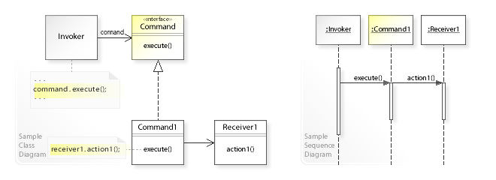

In the above UML class diagram, the Invoker class doesn't implement a request directly. Instead, Invoker refers to the Command interface to perform a request (command.execute()), which makes the Invoker independent of how the request is performed. The Command1 class implements the Command interface by performing an action on a receiver (receiver1.action1()).

The UML sequence diagram shows the run-time interactions: The Invoker object calls execute() on a Command1 object. Command1 calls action1() on a Receiver1 object, which performs the request.
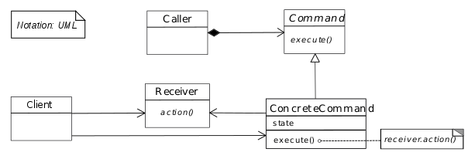

Why no class diagrams shows a relationship between Client and Invoker, since the client creates an instance of the Invoker (Caller) class ?

- This is because there may be a relation but there is no must for a relation.

Uses

GUI buttons and menu items

In Swing and Borland Delphi programming, an Action is a command object. In addition to the ability to perform the desired command, an Action may have an associated icon, keyboard shortcut, tooltip text, and so on. A toolbar button or menu item component may be completely initialized using only the Action object.

Macro recording

If all user actions are represented by command objects, a program can record a sequence of actions simply by keeping a list of the command objects as they are executed. It can then "play back" the same actions by executing the same command objects again in sequence. If the program embeds a scripting engine, each command object can implement a toScript() method, and user actions can then be easily recorded as scripts.

Multi-level undo

If all user actions in a program are implemented as command objects, the program can keep a stack of the most recently executed commands. When the user wants to undo a command, the program simply pops the most recent command object and executes its undo() method.

Networking

It is possible to send whole command objects across the network to be executed on the other machines, for example player actions in computer games.

Parallel Processing

Where the commands are written as tasks to a shared resource and executed by many threads in parallel (possibly on remote machines -this variant is often referred to as the Master/Worker pattern)

Thread pools

A typical, general-purpose thread pool class might have a public addTask() method that adds a work item to an internal queue of tasks waiting to be done. It maintains a pool of threads that execute commands from the queue. The items in the queue are command objects. Typically these objects implement a common interface such as java.lang.Runnable that allows the thread pool to execute the command even though the thread pool class itself was written without any knowledge of the specific tasks for which it would be used.

Transactional behavior

Similar to undo, a database engine or software installer may keep a list of operations that have been or will be performed. Should one of them fail, all others can be reversed or discarded (usually called rollback). For example, if two database tables that refer to each other must be updated, and the second update fails, the transaction can be rolled back, so that the first table does not now contain an invalid reference.

...
Consider a "simple" switch. In this example we configure the Switch with two commands: to turn the light on and to turn the light off.

- A benefit of this particular implementation of the command pattern is that the switch can be used with any device, not just a light. The Switch in the following Java implementation turns a light on and off, but the Switch's constructor is able to accept any subclasses of Command for its two parameters. For example, you could configure the Switch to start an engine.
- Allows you to set aside a list of commands for later use.
- You can store multiple commands in a class to use it over and over
- You can implement undo operations for past commands
- Negative : You create many small classes that store list of commands ( just meaning we get lots of small classes)

